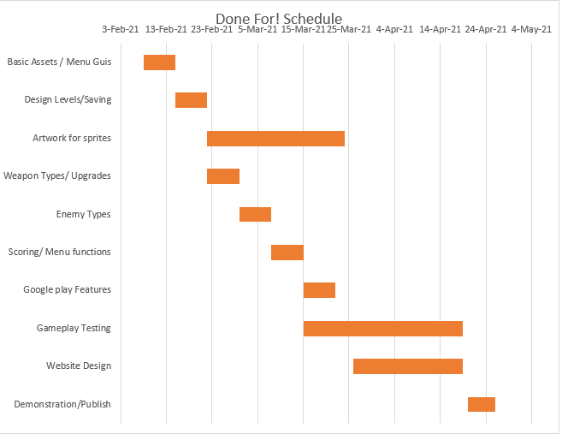

|  |  |  |
| --- | --- | --- |
|  | Start Date | Duration |
| Basic Assets / Menu Guis | 8-Feb-21 | 7 |
| Design Levels/Saving | 15-Feb-21 | 7 |
| Artwork for sprites | 22-Feb-21 | 30 |
| Weapon Types/ Upgrades | 22-Feb-21 | 7 |
| Enemy Types | 1-Mar-21 | 7 |
| Scoring/ Menu functions | 8-Mar-21 | 7 |
| Google play Features | 15-Mar-21 | 7 |
| Gameplay Testing | 15-Mar-21 | 35 |
| Website Design | 26-Mar-21 | 24 |
| Demonstration/Publish | 20-SchedApr-21 | 6 |